***This release and additional tables***

***of international statistics are***

***available on efama’s website***

***(***[***www.efama.org***](http://www.fefsi.org)***).***

## Worldwide Regulated Open-ended Fund Assets and Flows

**Trends in the First Quarter of 2020**

Brussels, June 22, 2020 **–** Worldwide regulated open-ended fund assets decreased by 10.8 percent to EUR 47.1 trillion in the first quarter of 2020.[1] Worldwide net cash flow to all funds amounted to EUR 617 billion, compared to EUR 808 billion in the fourth quarter of 2019.

The information presented in this report was compiled by EFAMA and the Investment Company Institute (ICI) on behalf of the International Investment Funds Association (IIFA), an organization of national investment fund associations. Statistics from 46 countries are included in this report.

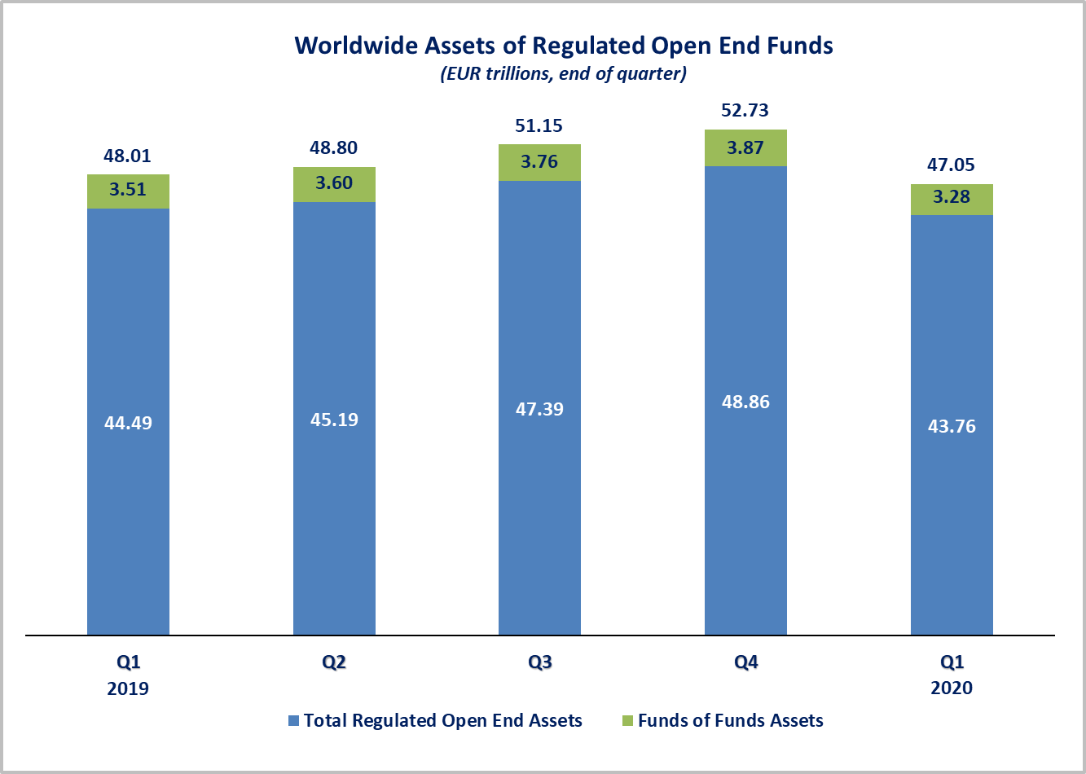

Measured in U.S. dollars, worldwide investment fund net assets decreased to USD 51.5 trillion at the end of Q1 2020. This represented a decrease of 13 percent. The following two graphs compare the net asset growth in the seven largest countries/regions.

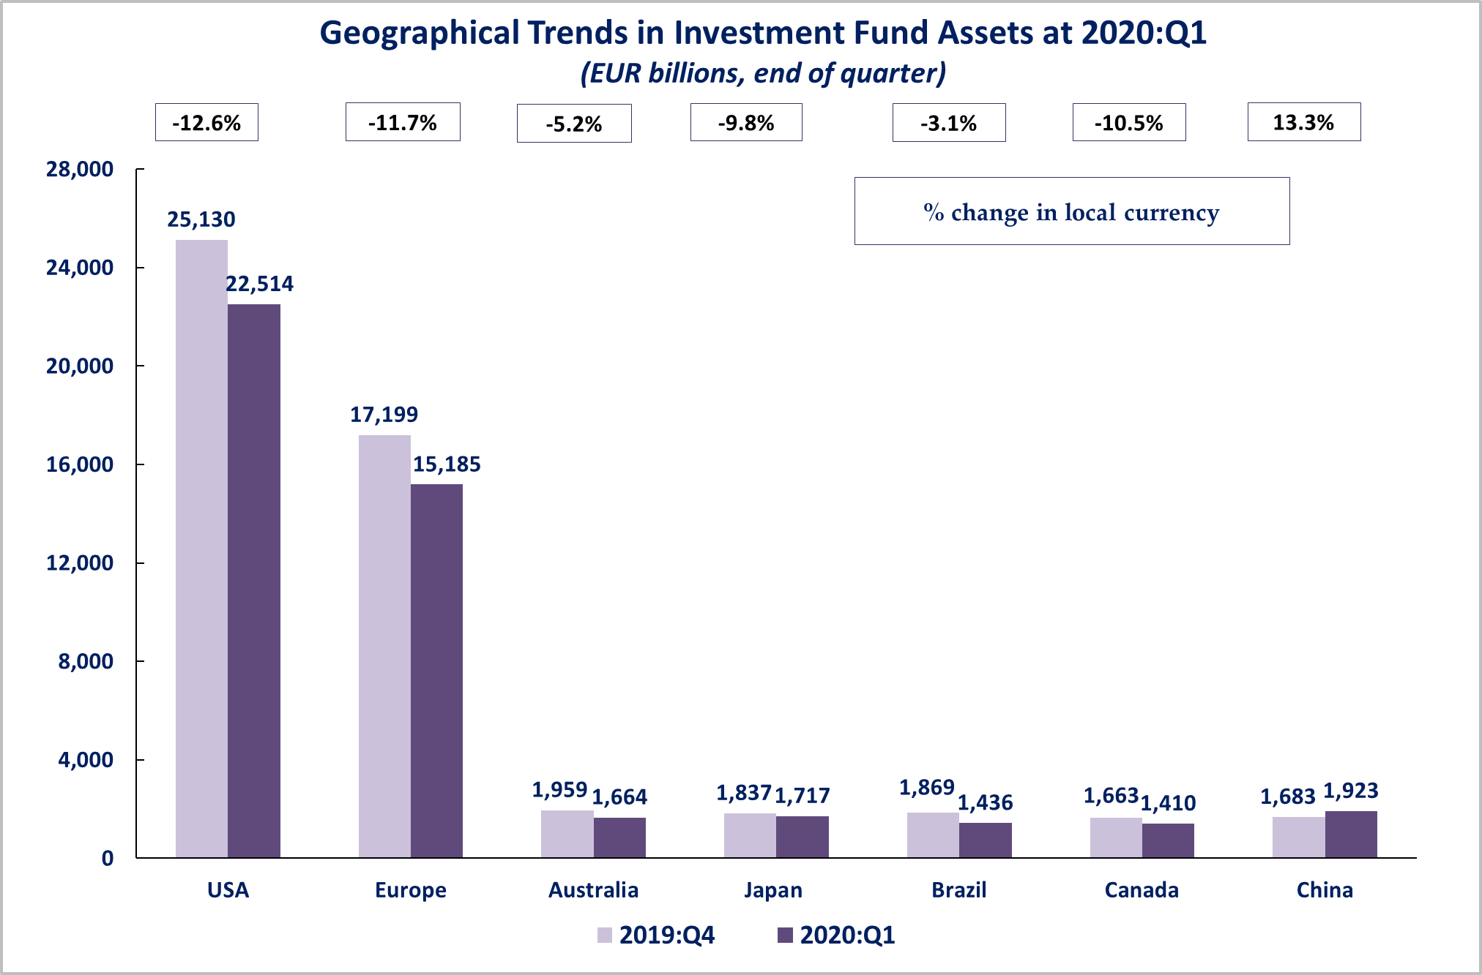



On a euro-denominated basis, worldwide equity fund assets decreased by 19.7 percent to EUR 17.8 trillion at the end of the first quarter of 2020. Bond fund assets decreased by 6.7 percent to EUR 10.2 trillion. Balanced/mixed fund assets decreased by 12.7 percent to EUR 7.9 trillion. Money market funds were the only type of fund to register an increase in net assets in Q1 2020, net assets increased by 13.7 percent to 7 trillion.



At the end of Q1 2020, 37.8 percent of worldwide regulated open-ended fund net assets were held in equity funds. The asset share of bond funds was 21.8 percent and the asset share of balanced/mixed funds was 16.9 percent. Money market fund assets represented 14.9 percent of the worldwide total.

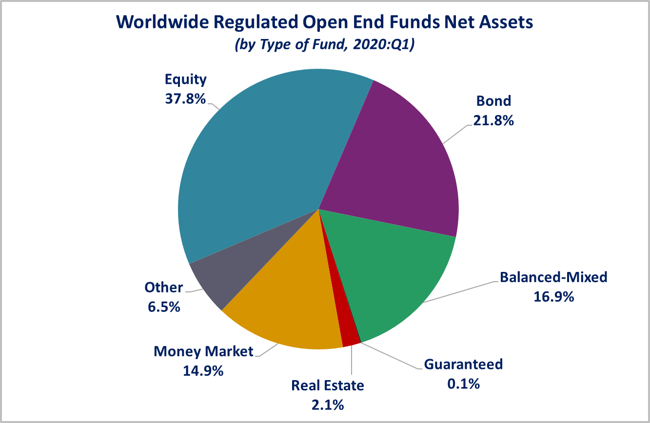

Looking at the worldwide distribution of investment fund net assets at end Q1 2020, the United States and Europe held the largest shares in the world market, with 47.9 percent and 32.3 percent, respectively. China (4.1%), Japan (3.7%), Australia (3.5%), Brazil (3.1%), Canada (3%), Rep. of Korea (1%), India (0.5%) and South Africa (0.3%) follow in this ranking.

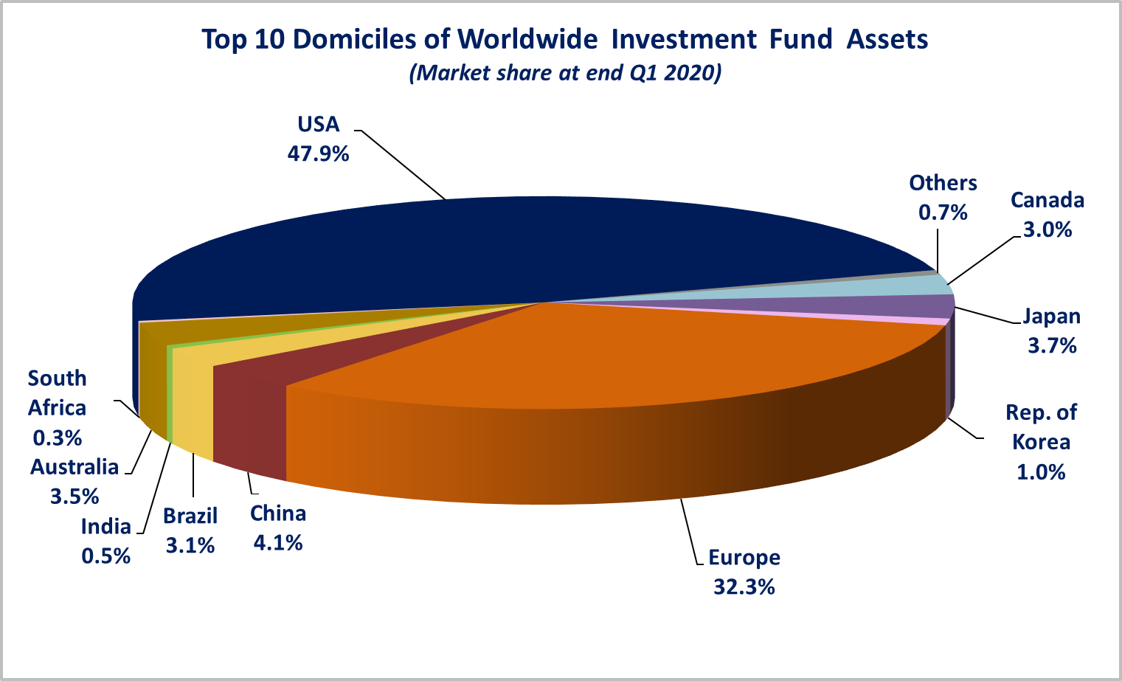

Overall, five European countries ranked among the top ten largest fund domiciles in the world: Luxembourg (with 8.8 percent of worldwide investment fund assets), Ireland (5.8%), Germany (4.6%), France (3.8%), and the United Kingdom (3%).

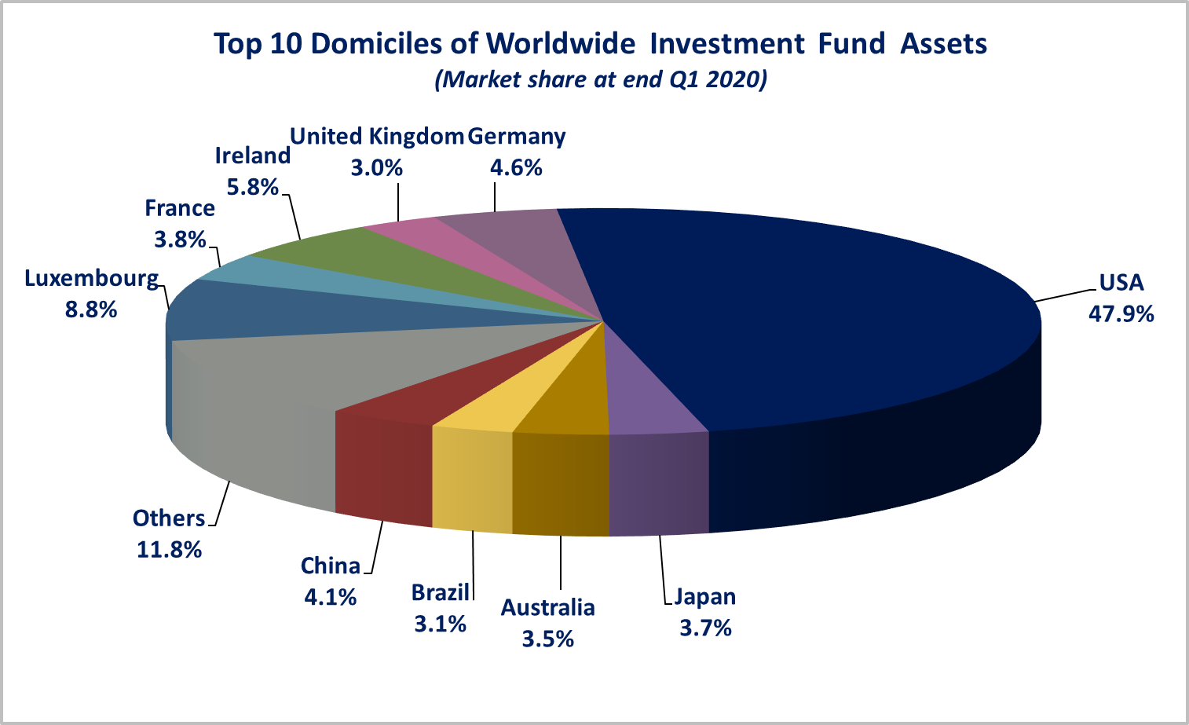

Worldwide net sales of regulated open-ended funds decreased to EUR 617 billion in the first quarter of 2020, from EUR 808 billion in Q4 2019. Long-term funds recorded net outflows of EUR 213 billion, compared to net inflows of EUR 548 billion in the previous quarter. Globally, bond funds recorded net outflows of EUR 207 billion, compared to net inflows of EUR 233 billion in the previous quarter. Net sales of equity funds registered net outflows of EUR 15 billion, compared to net inflows of EUR 134 billion in Q4 2019. Balanced/mixed funds worldwide recorded net outflows of EUR 39 billion, compared to net inflows of EUR 120 billion in Q4 2019. Net sales of money market funds surged up in Q1 2020, from EUR 259 billion in the previous quarter to EUR 829 billion in Q1 2020.

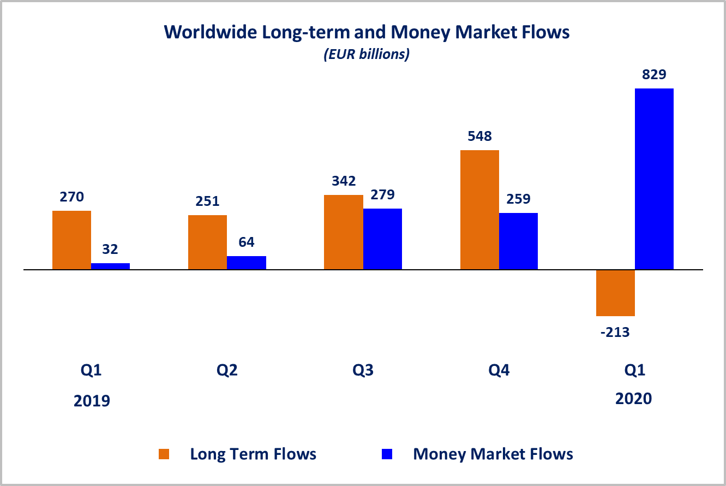Net sales of regulated open-ended funds reached EUR 423 billion in the United States, EUR 267 billion in Emerging markets[2] (of which net inflows of EUR 275 billion in China). Other advanced economies[3] recorded net inflows of EUR 48 billion, mainly driven by inflows in Canada (EUR 14 billion) and in Japan (EUR 24 billion).

Europe recorded net outflows of EUR 122 billion (of which net outflows of EUR 77 billion in Luxembourg and net outflows of EUR 41 billion in Ireland).

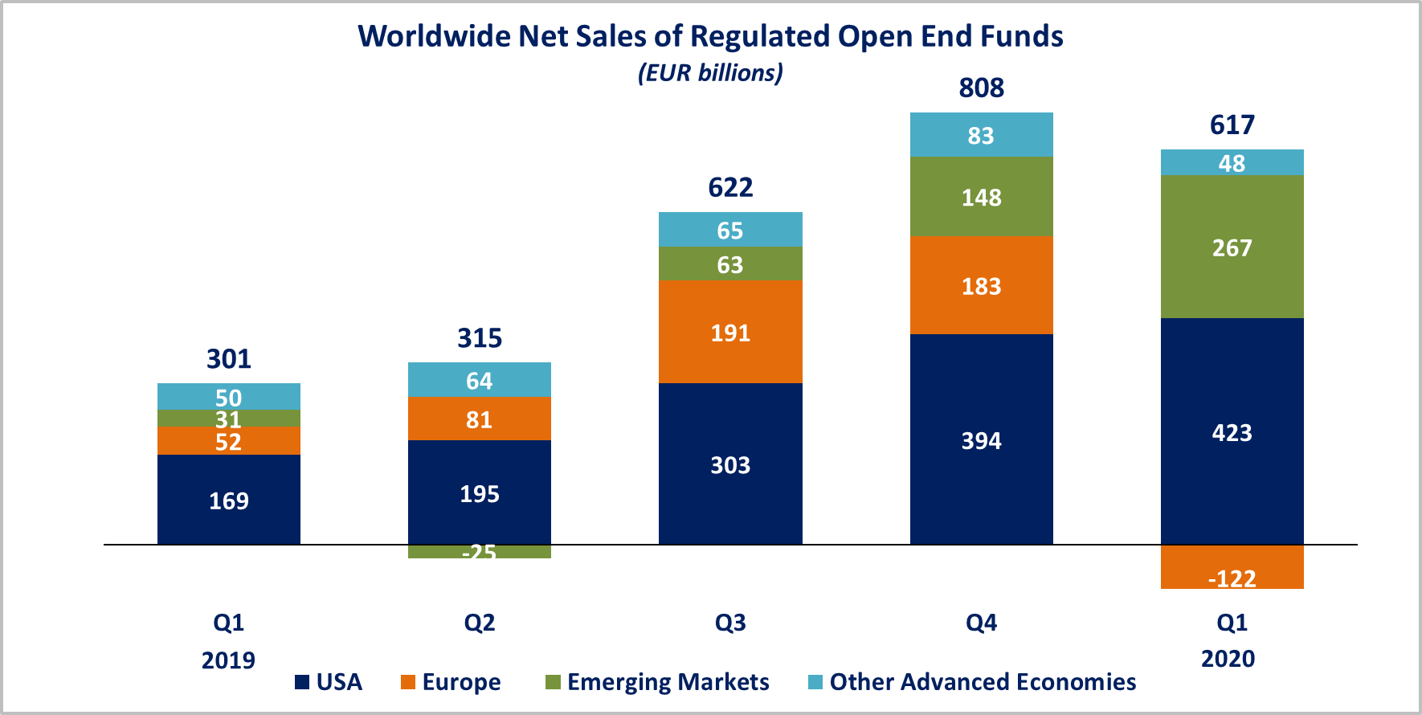

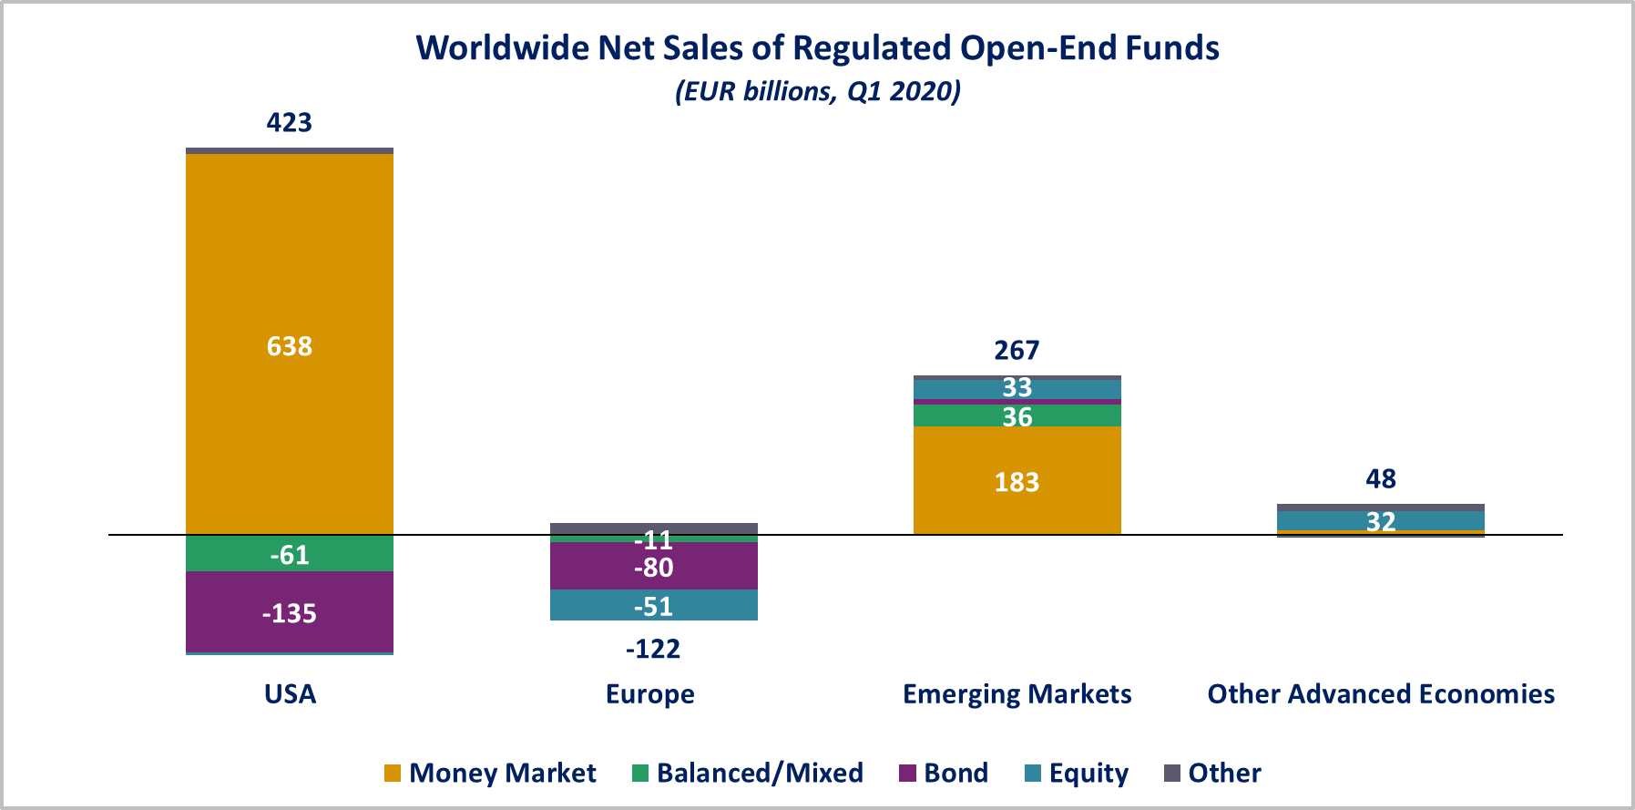

In Europe, long-term funds recorded net outflows of EUR 122 billion, compared to net inflows of EUR 188 billion in the fourth quarter of 2019. Equity funds recorded net outflows of EUR 51 billion, compared to net inflows of EUR 54 billion in Q4 2019. Bond funds recorded net outflows of EUR 80 billion, compared to net inflows of EUR 37 billion in the previous quarter. Balanced/mixed funds registered net outflows of EUR 11 billion, compared to net inflows of EUR 58 billion in Q4 2019. Money market funds recorded net outflows of EUR 0.1 billion, compared to net outflows of EUR 5 billion in the fourth quarter of 2019.

In the United States, long-term open-ended funds recorded net outflows of EUR 215 billion, compared to net inflows of EUR 222 billion in Q4 2019. Equity funds recorded net outflows of EUR 29 billion, compared to net inflows of EUR 33 billion in the previous quarter. Bond funds recorded net outflows of EUR 135 billion, compared to net inflows of EUR 158 billion in Q4 2019. Balanced/mixed funds registered net outflows of EUR 61 billion, compared to net inflows of EUR 32 billion in the fourth quarter of 2019. Net sales of money market funds rose to EUR 638 billion, up from EUR 171 billion in the previous quarter.

**Regional Summary Table by Type of Fund, Q1 2020**



1. All data presented in this report include funds of funds, exchange-traded funds and institutional funds.
2. Emerging markets are countries thus defined by the International Monetary Fund. Data is not available for all emerging markets. The following countries are included: Argentina, Brazil, Chile, China, Costa Rica, India, Mexico, Pakistan, the Philippines and South Africa.
3. Other advanced economies are countries thus defined by the International Monetary Fund, based on criteria such as per capita income level and the degree of integration into the global financial system, excluding the US and the countries included in the Europe aggregate. Data is not available for all advanced economies. Other advanced economies include Australia, Canada, Japan, Korea, New Zealand and Chinese Taipei (Taiwan).